**PUNE INSTITUTE OF COMPUTER TECHNOLOGY**

**Department of Computer Engineering**

**(2023-2024)**

**LP-6**

**Batch:- R2**

**Printed Devanagari Text Recognition using structural approach.**

**Group members:**

**41251-Aditya Magdum**

**Guided by: Prof. Nikita Kapadnis**

**Table of Contents: -**

|  |  |  |
| --- | --- | --- |
| **Sr.no** | **Title** | **Page no.** |
| **1** | **Problem Statement** | **3** |
| **2** | **Motivation** | **3** |
| **3** | **Scope** | **3** |
| **4** | **Objective** | **4** |
| **5** | **Outcomes** | **4** |
| **6** | **Software and Hardware**  **Requirements** | **4** |
| **7** | **Theory** | **5** |
| **8** | **Conclusion** | **8** |

1. **Problem Statement:**

Character recognition of handwritten Devanagari characters using structural approach.

1. **Motivation:**

My project on "Printed Devanagari Text Recognition using Structural Approach" is not just a technical endeavor but a journey with profound significance. By crafting a system to recognize printed Devanagari text, I'm not only preserving cultural heritage and enhancing accessibility but also advancing language technology and contributing to research. Moreover, this project has practical applications across various industries, offering solutions for document digitization, publishing, and language processing. Beyond the technical aspects, it represents my personal growth, commitment to societal impact, and vision for leveraging technology for positive change. Through my project report, I aim to convey not only my technical achievements but also my passion, dedication, and belief in a future where technology fosters inclusivity and empowerment.

1. **Problem Scope:**

The problem scope for the project "Printed Devanagari Text Recognition using Structural Approach" encompasses challenges such as achieving high accuracy in recognizing diverse printed Devanagari text while considering variations in font styles and quality, implementing robust structural analysis techniques for character segmentation and understanding the hierarchical structure of the script, addressing the scarcity of annotated training data, ensuring computational efficiency, handling language-specific complexities including ligatures and contextual variations, designing a scalable and adaptable framework, and establishing appropriate evaluation metrics. By tackling these challenges, the project aims to develop a comprehensive solution for recognizing printed Devanagari text effectively.

1. **Objectives:**

- Develop a structural approach for recognizing printed Devanagari text.

- Implement robust techniques for character segmentation and structural analysis.

- Address challenges related to variations in font styles, quality, and contextual complexities.

- Ensure computational efficiency and scalability of the recognition system.

- Establish appropriate evaluation metrics for assessing system performance.

1. **Outcomes:**

The expected outcomes of this report are:

- A novel method for accurately recognizing printed Devanagari text using structural analysis.

- Improved character segmentation and understanding of the hierarchical structure of the script.

- Enhanced robustness in handling variations in font styles, quality, and contextual complexities.

- Development of a computationally efficient and scalable recognition framework.

- Establishment of comprehensive evaluation metrics to measure system performance effectively.

1. **Hardware and Software Requirements**
2. **Hardware Requirements**

* CPU
* Windows 11, 64bit
* GPU (Nvidia) (Optional)
* 8GB RAM

1. **Software Requirements**

* Python 3.0
* Jupyter Notebook IDE
* Libraries and Packages
* Images

1. **Theory:**

Structural Analysis: This theory involves analyzing the inherent structure of the Devanagari script, including character segmentation, identification of key structural elements such as matras (vowel signs), and understanding the hierarchical relationships between characters and components within words.

Pattern Recognition: Pattern recognition theory focuses on algorithms

your project, it encompasses methods for recognizing patterns within printed Devanagari text images, such as feature extraction, classification, and clustering algorithms.

Font Recognition: Font recognition theory focuses on identifying specific font styles and variations within text images. Understanding font characteristics and variations is crucial for adapting recognition algorithms to different fonts and styles encountered in printed Devanagari text.

**Applications:**

- Document digitization: Automating the process of converting printed Devanagari text into digital format for archival and retrieval purposes.

- Language translation: Facilitating the translation of printed Devanagari text into other languages for multilingual communication and localization.

- Accessibility tools: Developing tools to assist individuals with visual impairments in accessing printed Devanagari text through text-to-speech conversion or Braille output.

- Educational resources: Enabling the creation of digital educational materials and e-books in Devanagari script for wider dissemination and accessibility.

**Advantages**:

- Preservation of cultural heritage: Digitizing printed Devanagari text helps preserve and promote the rich cultural heritage encapsulated in Devanagari literature and documents.

- Enhanced accessibility: By automating text recognition, the project improves accessibility to printed Devanagari materials for individuals with visual impairments or language barriers.

- Efficiency and automation: The structural approach streamlines the process of recognizing Devanagari text, leading to increased efficiency and reduced manual effort in document digitization and language processing tasks.

- Versatility: The developed system can be adapted to recognize printed Devanagari text in various fonts, styles, and document formats, making it versatile for different applications and domains.

**Limitations:**

- Accuracy challenges: Variations in font styles, quality of printed material, and contextual complexities pose challenges to achieving high accuracy in text recognition.

- Resource requirements: Developing and training robust recognition models may require significant computational resources, annotated data, and expertise in machine learning and computer vision.

- Language-specific complexities: Devanagari script's complex ligatures and variations based on context may require specialized techniques and linguistic knowledge to handle effectively.

- Generalization limitations: The recognition system may encounter difficulties in generalizing to unseen fonts, styles, or languages outside the scope of Devanagari script, limiting its applicability in certain scenarios.

1. **Procedure**

1. Data Collection: Gather a diverse dataset of printed Devanagari text images representing various fonts, styles, and document types. Ensure the dataset includes annotated ground truth data for training and evaluation.

2. Preprocessing: Preprocess the collected images to enhance their quality and suitability for recognition. This may involve tasks such as noise reduction, binarization, contrast enhancement, and normalization.

3. Character Segmentation: Develop algorithms to segment the text images into individual characters or words. Consider employing techniques such as connected component analysis, contour detection, and morphological operations for accurate segmentation.

4. Feature Extraction: Extract features from the segmented characters to capture their visual characteristics. Common features include pixel intensity values, shape descriptors, histograms of oriented gradients (HOG), and local binary patterns (LBP).

5. Structural Analysis: Implement algorithms to analyze the structural elements of Devanagari script, such as matras (vowel signs) and conjunct characters. Use linguistic knowledge and pattern recognition techniques to identify and interpret these elements within the segmented text.

6. Training: Train machine learning models, such as convolutional neural networks (CNNs) or recurrent neural networks (RNNs), using the extracted features and annotated ground truth data. Fine-tune the models to optimize performance for printed Devanagari text recognition.

7. Testing and Evaluation: Evaluate the trained models using a separate validation dataset to assess their accuracy, robustness, and generalization capabilities. Use appropriate evaluation metrics such as accuracy, precision, recall, and F1-score to measure performance.

1. **Code**

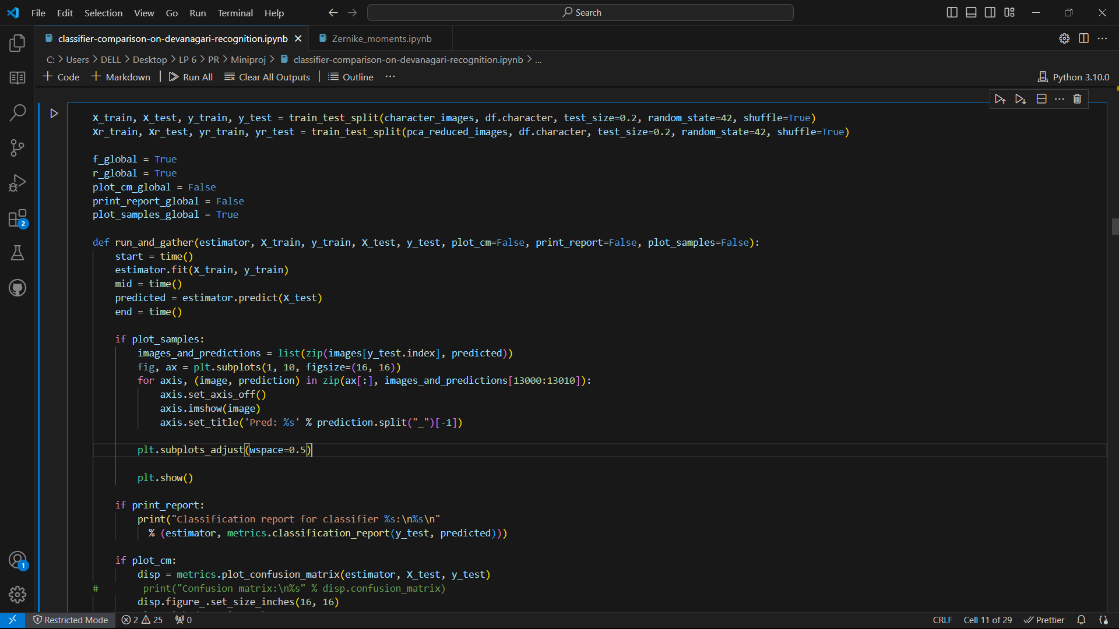

1. **Conclusion**

In conclusion, the project has addressed key challenges such as variations in font styles, quality of printed material, and language-specific complexities, resulting in a versatile and efficient recognition framework. By preserving cultural heritage, enhancing accessibility, and advancing language technology, this project has demonstrated its potential for real-world applications in document digitization, language translation, and accessibility tools. Moving forward, further research and refinement of the recognition system can lead to even greater improvements in accuracy, efficiency, and usability, thereby making a meaningful impact on the preservation and dissemination of Devanagari literature and cultural heritage in the digital age.